|  |  |  |  |
| --- | --- | --- | --- |
| figcAuthor  Hongkai Xiao | Department | Signature (if not signed electronically) | Signature Date |
| Title  PPS Auto Smoke Test Solution | | | |

|  |  |  |  |
| --- | --- | --- | --- |
| **Reviewed** (if not signed electronically) | **Department** | **Signature** (if not signed electronically) | **Signature Date** |
| <Full name> |  |  |  |

|  |  |  |  |
| --- | --- | --- | --- |
| **Approved** (if not signed electronically) | **Department** | **Signature** (if not signed electronically) | **Signature Date** |
| <Full name> |  |  |  |

Contents

1. SUMMARY 3

2. Introduction 3

2.1. Purpose 3

2.2. Scope 3

2.3. Terminology 3

2.4. References 3

2.5. Revision History 3

3. Smoke test pipeline 4

4. test for service web ui 5

4.1. Technical framework 5

4.2. Test context 5

5. test for service interface 5

5.1. Technical framework 5

5.2. Test environment deployment 6

5.3. Test scripts hierarchy 6

5.4. Test context 6

# SUMMARY

This document describes the process of auto smoke test and technical framework used.

# Introduction

## Purpose

This document describes the process of auto smoke test and technical framework used.

## Scope

This scope covers auto smoke test in PSS.

## Terminology

|  |  |
| --- | --- |
| Term | Meaning |
|  |  |

## References

|  |  |
| --- | --- |
| Document Id | Document Title |
|  |  |

## Revision History

|  |  |  |  |
| --- | --- | --- | --- |
| Edition | Date | Author | Description |
|  |  |  |  |
|  |  |  |  |

# Smoke test pipeline

**3.1 Pipeline flow chart**



# test for service web ui

## Technical framework

Pytest + DrissionPage

## Test environment deployment

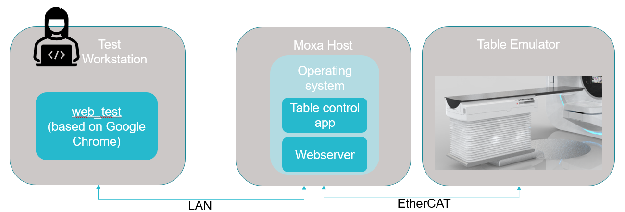

## Test scripts hierarchy

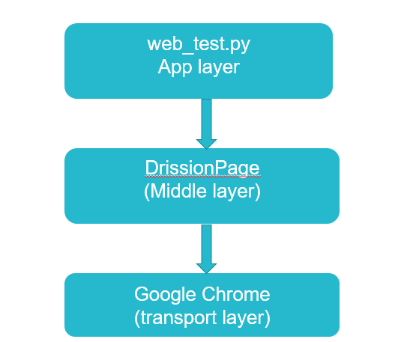

## Test context

1. User login and X/Y/Z/P/R/ISO axes calibration

# test for service interface

## Technical framework

Pytest auto test framework

## Test environment deployment

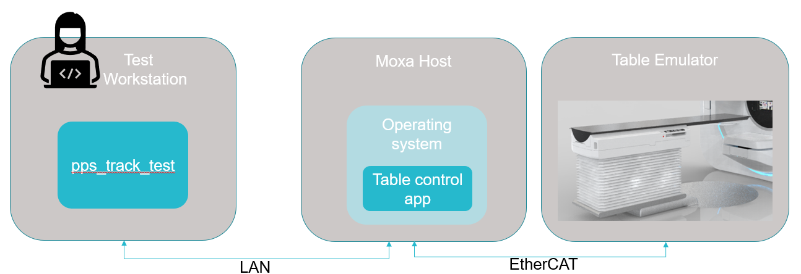

## Test scripts hierarchy

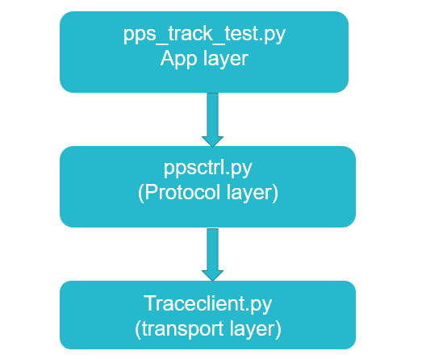

## Test context

1. Run one cycle of X/Y/Z/P/R/ISO axes position move

# reboot moxa MAHCINE

## Implementation technology

Python + Paramiko, using SSHClient provided by Paramiko to login MOXA and reboot it.

# send test results by mail

## Implementation technology

Python + smtplib, using smtp provided by smtplib to send email.

## Send context

results_service_ui.html, output of running web_test.py

results_service_if.html, out put of running pps_track_test.py

pipeline_log.txt, output of running pipeline.py